**Module-2: Case Study**

1. **Created an instance US-East-1 (N. Virginia) with Linux OS**

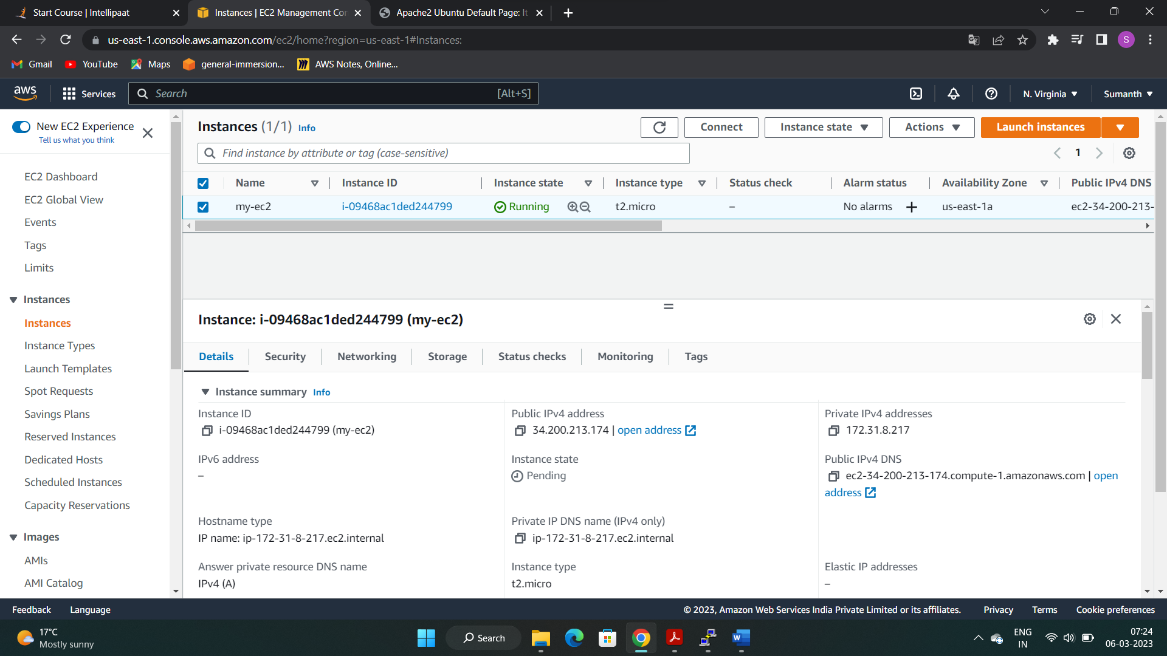

1. **Installed Apache2 for making web servers**

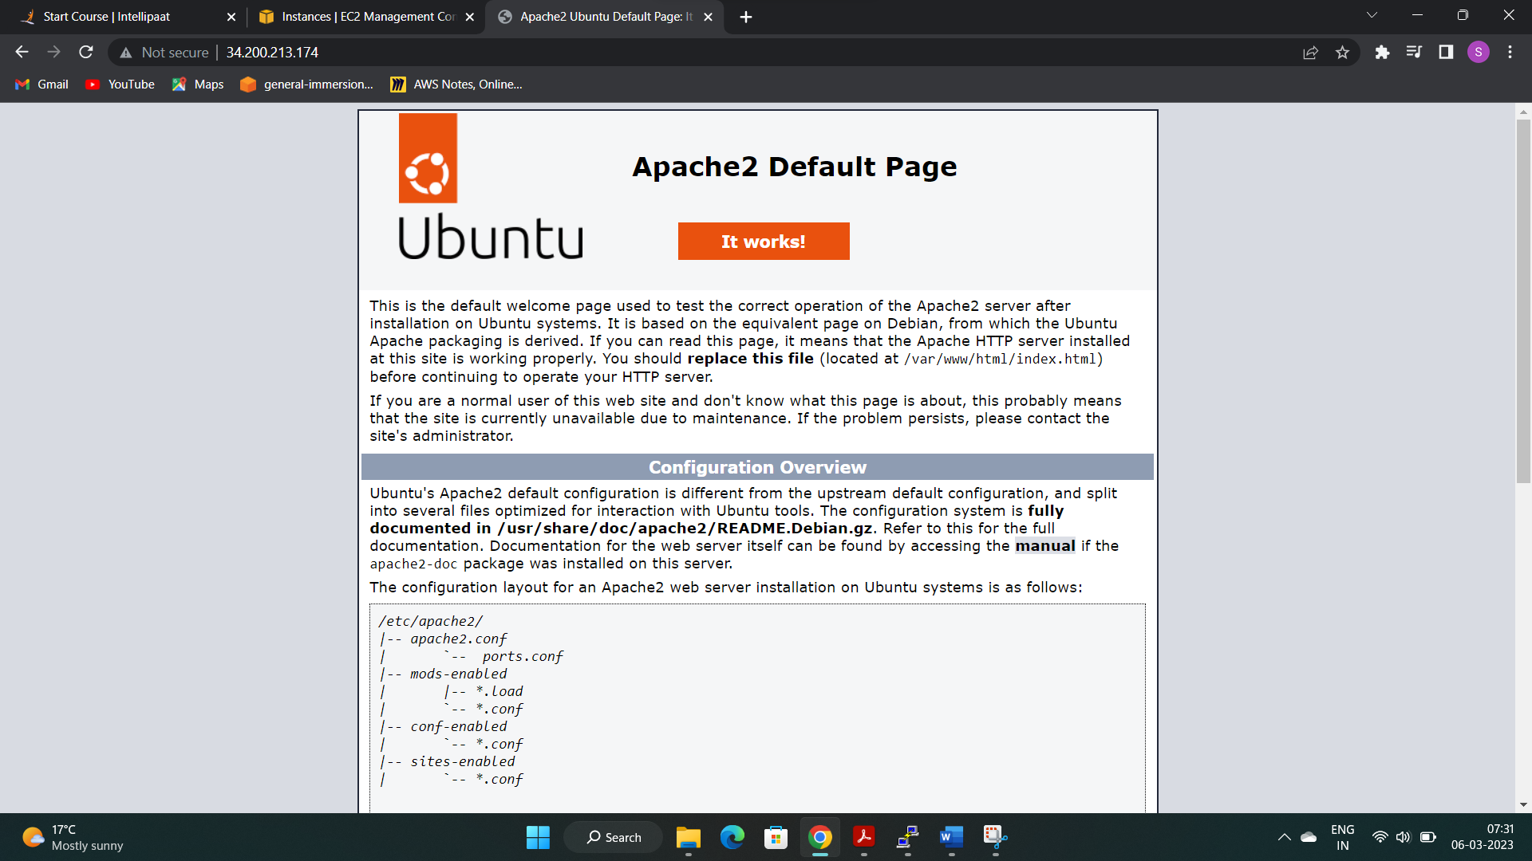

1. **Changed the default website**

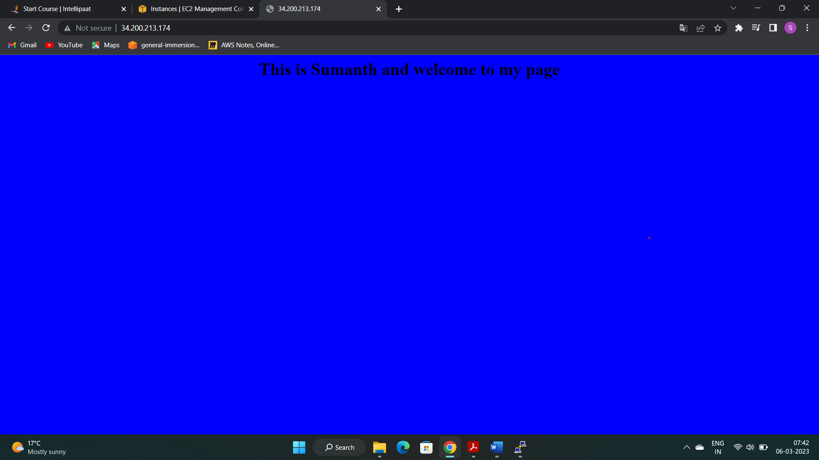

1. **Replicated the instance in US-West-2 (Oregon) region**

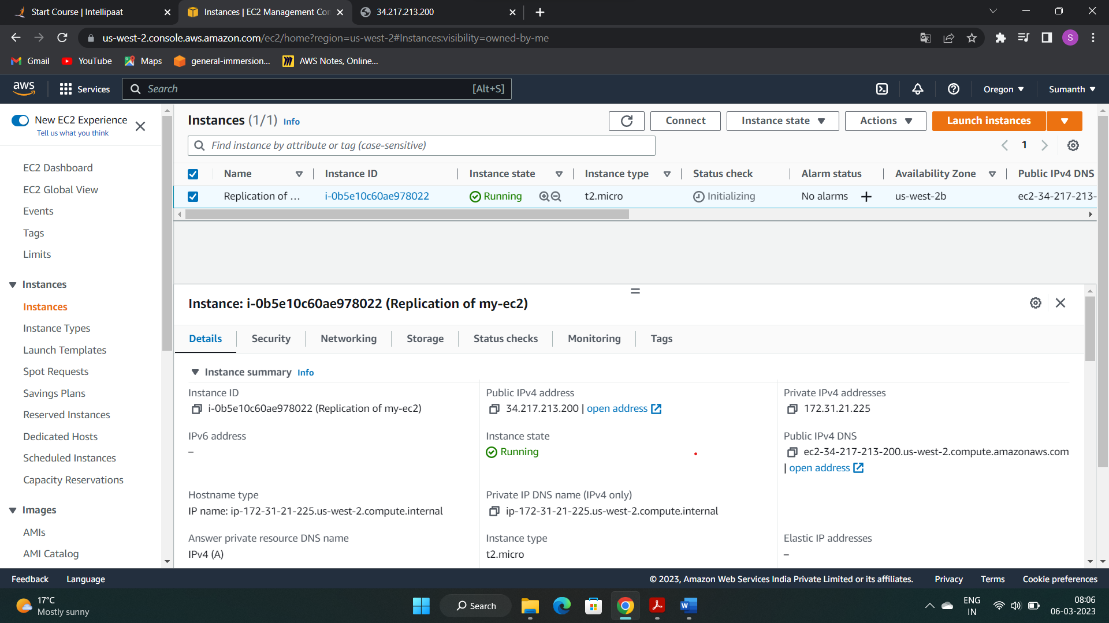

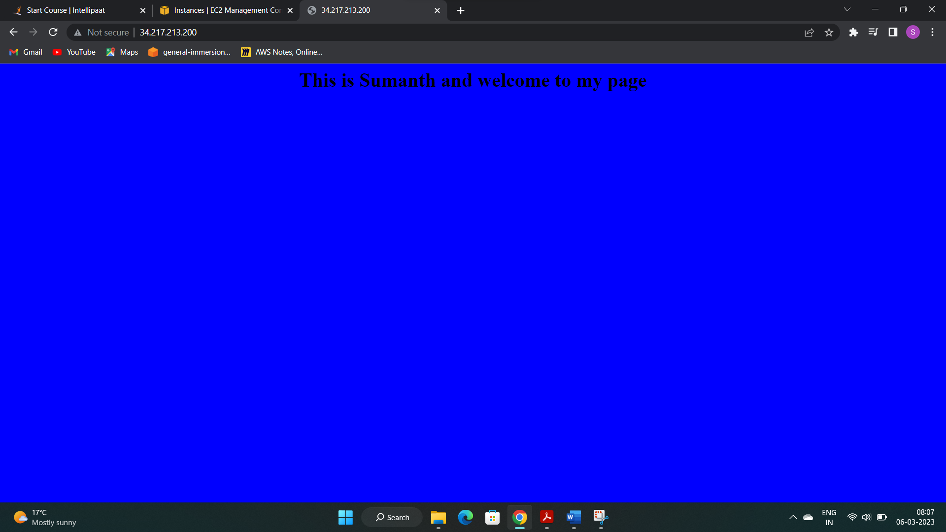

1. **Created 2 EBS Volumes and attached that to my instance**

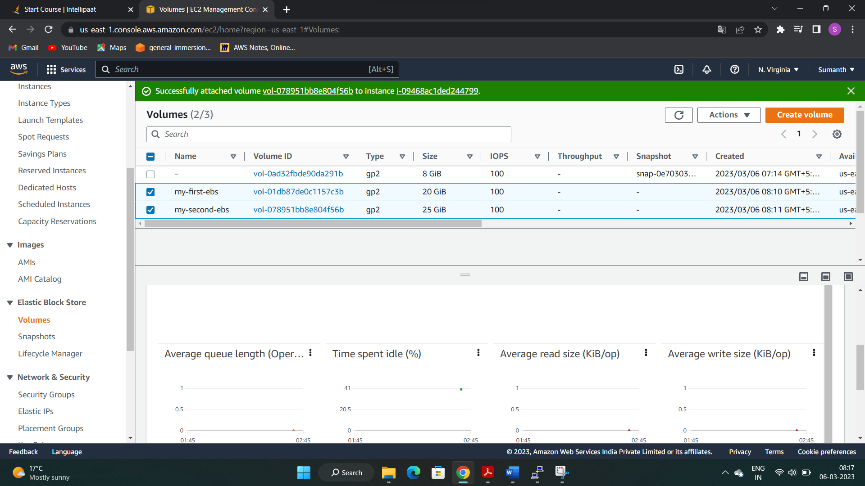

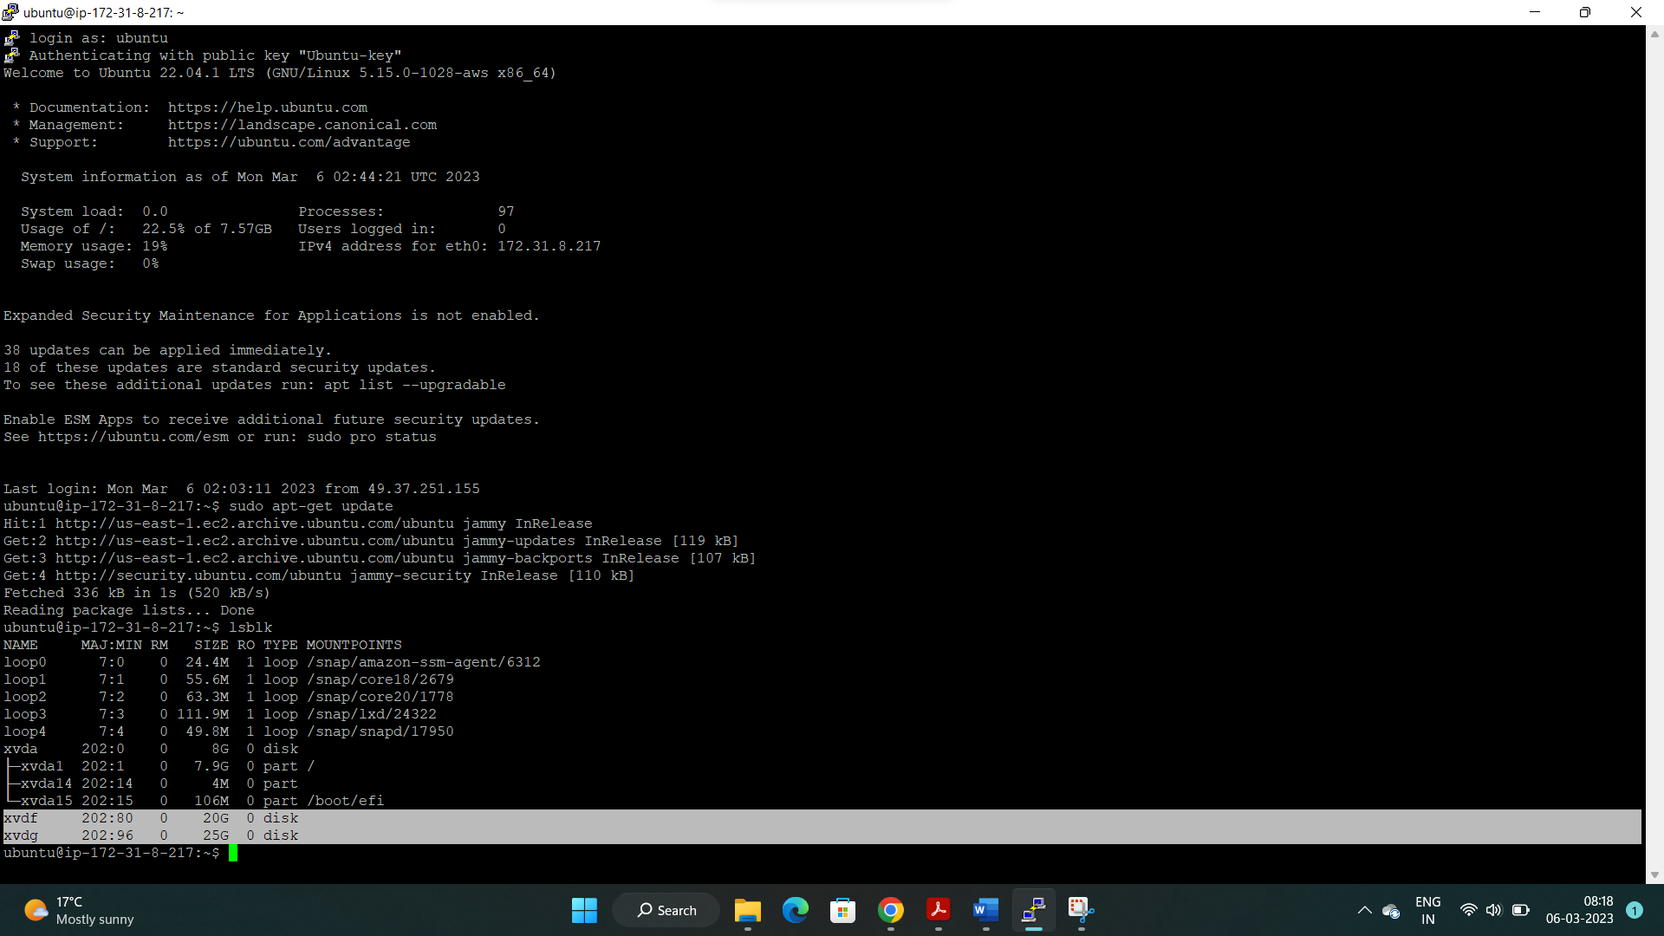

1. **Detached and deleted an EBS and extended the size of the other EBS**

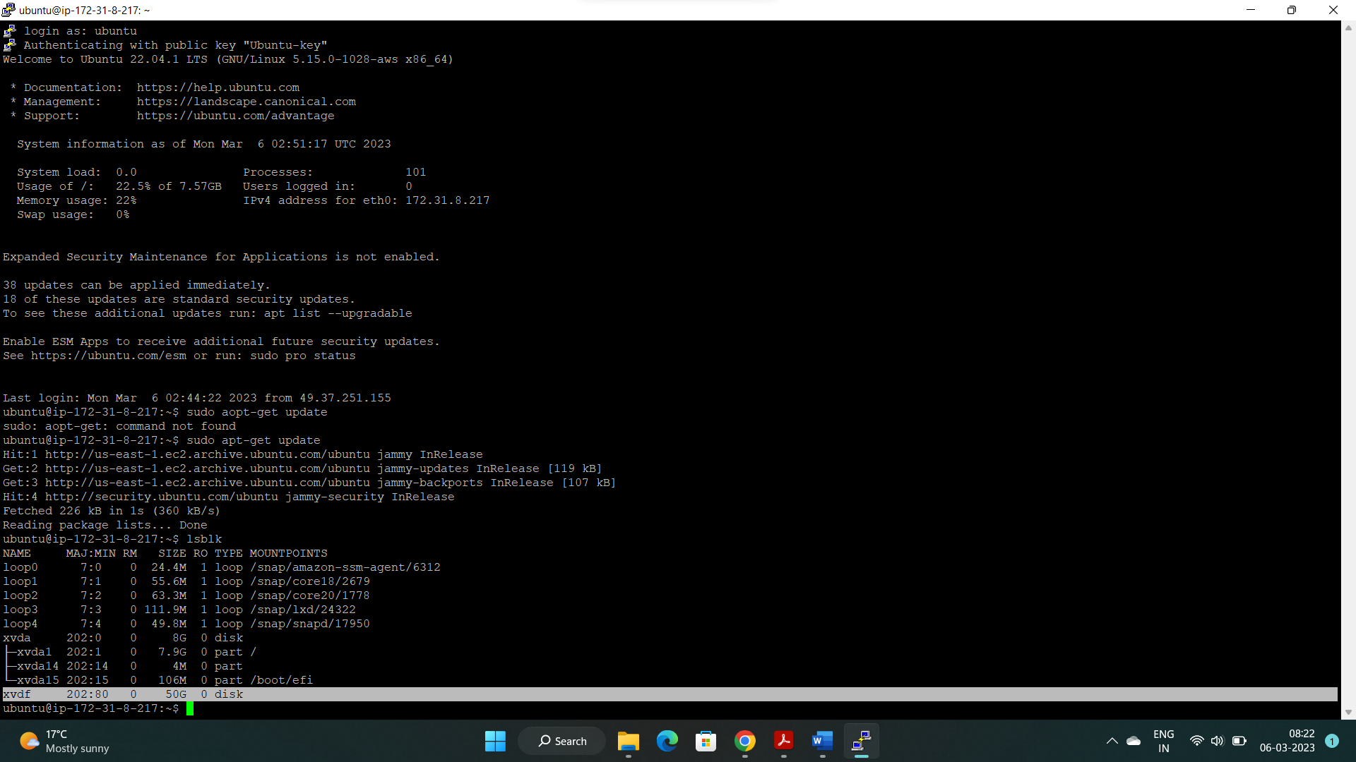

1. **Took the backup of the EBS volume**

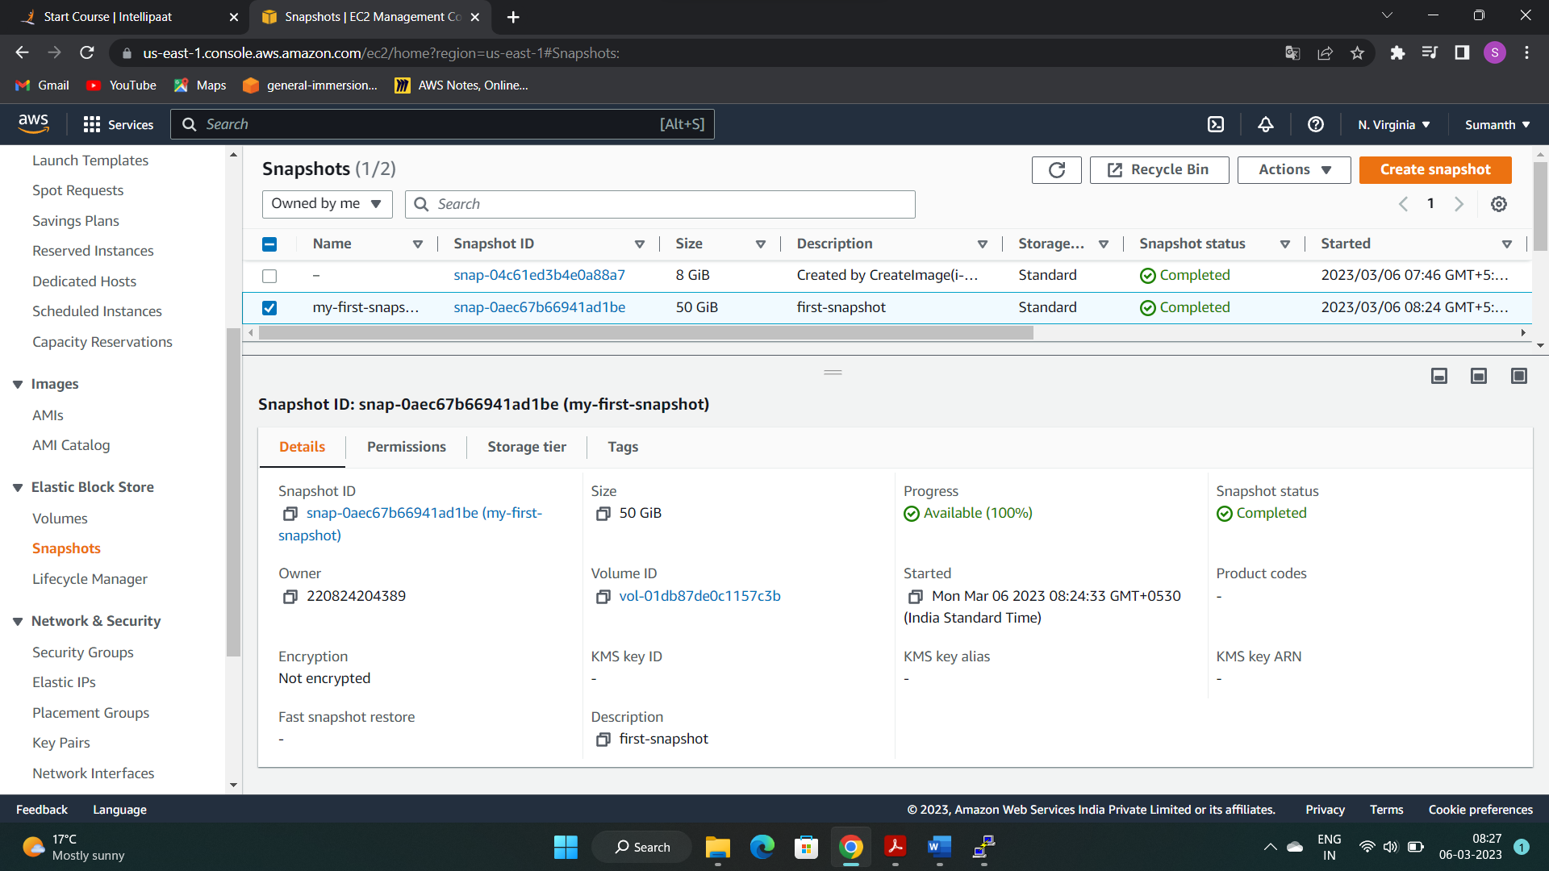

1. **Terminated all the services**